ACLC College of Ormoc
Data Analysis

Name : Lian Emmanuel V. Bugtai Section\Year : B.S.I.T. 2A

ACTIVITY 1:
DOWNLOAD PYTHON
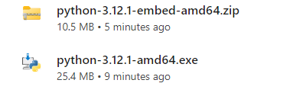
VERIFY INSTALLATION:
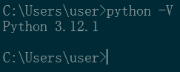

ACTIVITY 2:
SETUP A DEVELOPMENT ENVIRONMENT
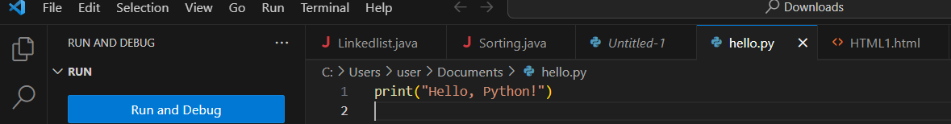

ACTIVITY 3:
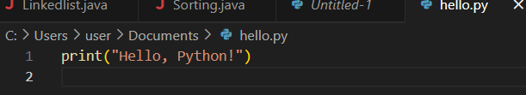
RUN THE SCRIPT:
